* **Smart Watch – User Research, Persona Creation & Journey Mapping**
* ***User Research for Smart Watch***

**OBJECTIVE –**

* *To Understand how users interact with smartwatches for fitness, productivity, and daily tasks.*
* *Identify key frustrations and areas for improvement.*
* *Improve usability, battery life, and health-tracking accuracy.*

**METHODS** *–*

* *Gather data on smartwatch usage habits.*
* *Talk to fitness enthusiasts, professionals, and tech users*
* *Study existing smartwatches and their drawbacks*
* *Observe users setting up and interacting with a smartwatch.*

***Key Insights –***

* *Users want longer battery life (2+ days without charging).*
* *Health tracking must be accurate (heart rate, sleep monitoring, SpO2 levels)*
* *Some users struggle with setup & syncing with their smartphones.*
* *Smartwatches with sleek design & customizable faces appeal more to younger users.*
* ***USER PERSONA –***

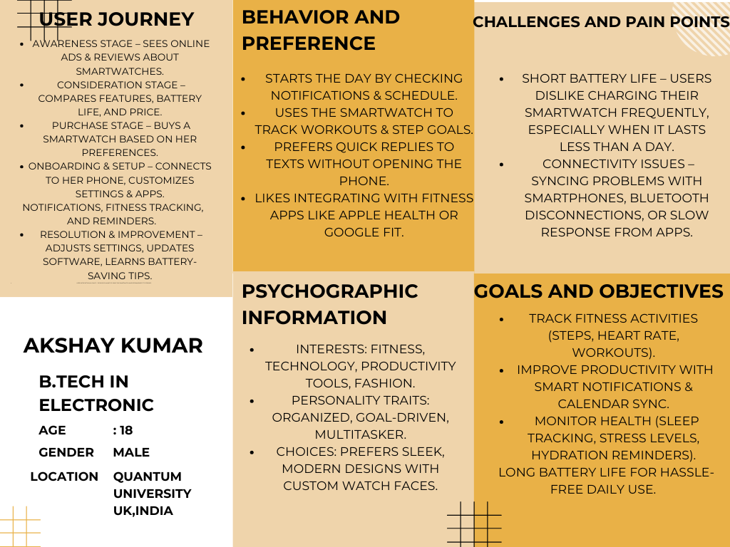

* ***USER JOURENY MAPPING –***

